ASR 5638

Change the storer from IBMPDL to IBMMSPL.

New Company name: IBM Manufacturing Solutions Pte. Ltd.

Sales Organization remain as 0909

As conversed, IBM Ireland Product Distribution Limited Singapore Branch (IPDL) will be transferred to **IBM Manufacturing Solutions Pte. Ltd.** from 01 November onwards.   
  
Please do the necessary arrangements and ensure that Schenker's WMS system is updated with the correct name and the shipping labels will print out as IBM Manufacturing Solutions Pte. Ltd. with effect from 02 November.   
  
The name on the live report from Schenker will also need to be updated. STC should be changed to OSC.

|  |
| --- |
| [$E3A28E425748EA7.jpg] |

Date: 16 Oct 2015

Below Action Required From System:   
System changes:   
1.     **Master Setup** – Create new storer and SKU master for IBMMSPL   
2.     **Billing Report** – Create new storage billing for New storer   
3.     **EC interface import** – ~~to add new storer import SO function~~ no changes.  
4.     **Live Report** – Add new Storer and change the main report folder name.   
    
Action after IBMPDL activities freezed:   
5.     **Inventory transfer** – Operation to perform inventory transfer for stock IBMPDL to IBMMSPL after operation cut-off for activities under IBM

[2015.10.20]

TEST User: ibmsd.test / 12341234

**Pre-migration scripts:**

1. 00_insert Storer.sql - Create storer, SKU
2. 01_Tranfer IBMPDL.sql – to Transfer stock

HUB Deployment:

ibm_setup.pbd

ibm_cyclecount.pbd

ibm_report.pbd

ibm_outbound.pbd

ibm_inbound.pbd

Scripts:

Inventory reports:

SCH_IBMSTC_HUB_Report_Inventory_byIDDN_IBMPO_Report.sql

SCH_IBMSTC_HUB_Report_Inventory_Report.sql

sp_04_SCH_IBMSTC_LiveReport_Inventory_Report.sql

sp_05_SCH_IBMSTC_LiveReport_Inventory_Aging_Report.sql

sp_06_SCH_IBMSTC_LiveReport_Inventory_Exception_Report.sql

HUB Screen:

Inbound

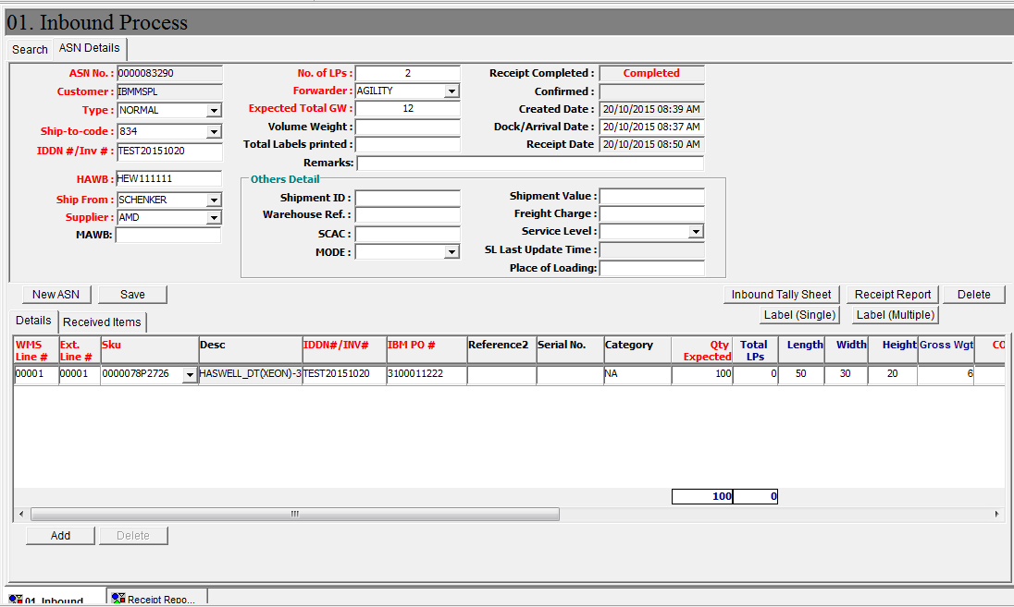

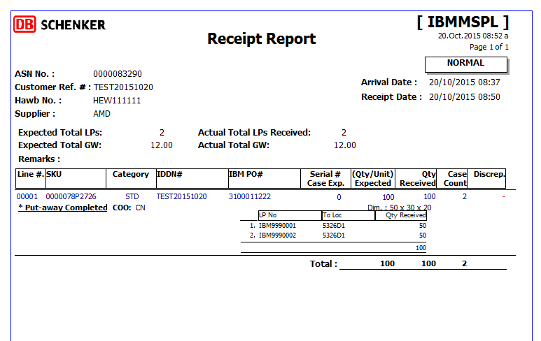

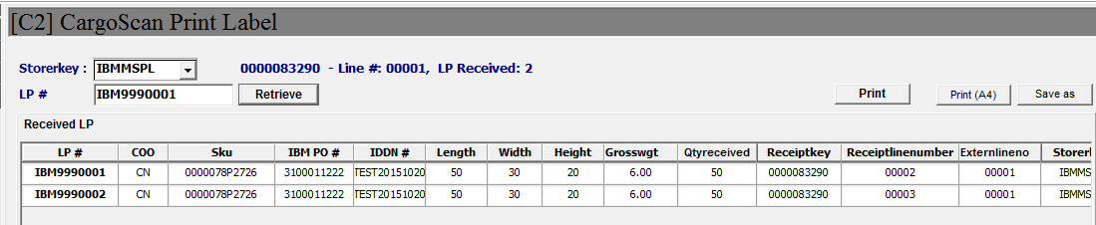

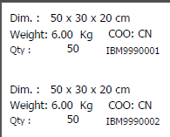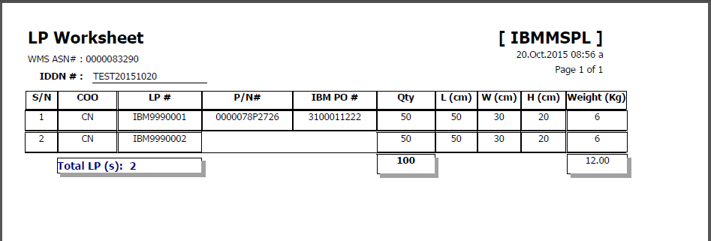

Outbound:

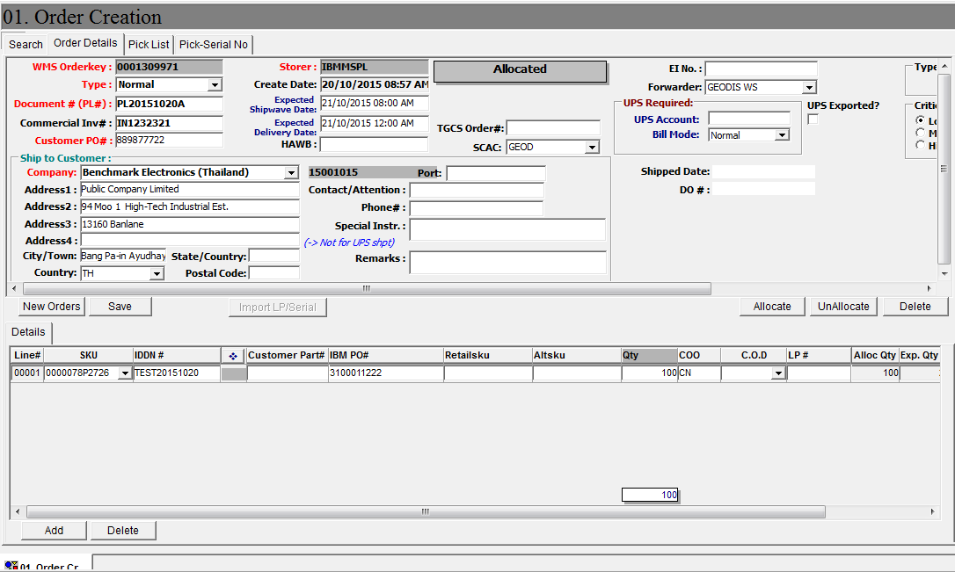

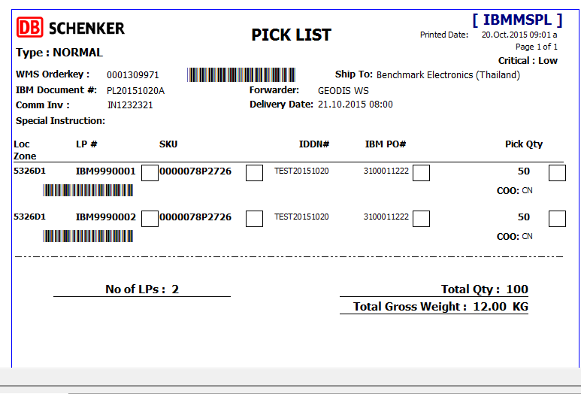

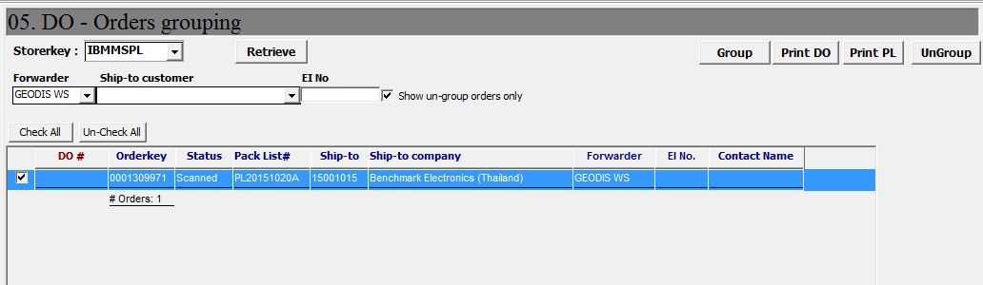

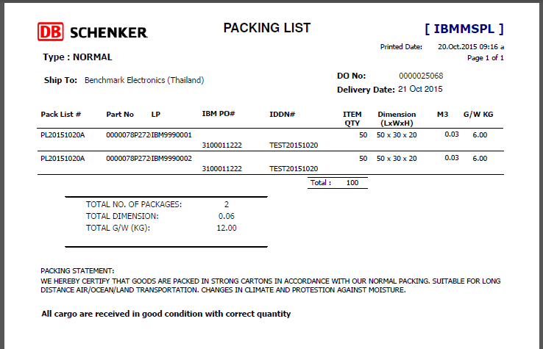

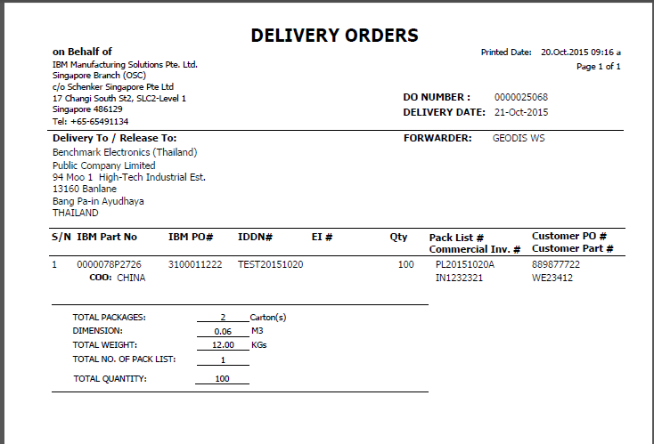

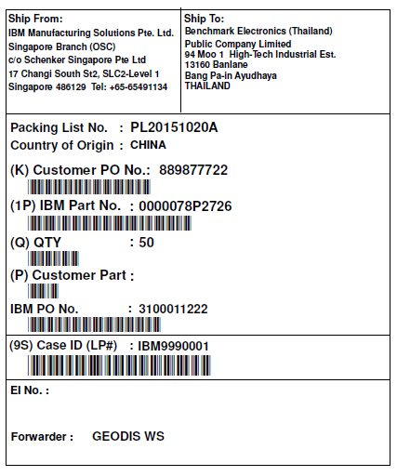

Reports:

